Printed Documentation
Table Of Contents
Concepts and Practices 3
Concepts and Practices 3
Journal Entry 4
The Detail Transaction Register 6
Recurring Journal Entry Processing 7
Period End Processing 8
Getting Started 9
General Ledger Menus 9
Setting Up a Company 12
Parameters 14
Parameters - General Ledger Tab 14
Parameter - Department Tab 24
Parameters - Cash Basis Options Tab 26
Parameters - Financial Statement Tab 28
General Ledger Setup 29
Department Title Setup Screen 29
Fiscal Year Setup Screen 30
G/L Account Break Setup Screen 32
Source Journal Code Setup 33
Account Balance Setup and Inquiry 36
Account Balance Graphic 38
Hard Copy Option 39
Daily and Periodic Processes 41
General Ledger Journal Entry 41
General Ledger Lines 44
General Ledger Journal Update 48
Recurring Journal Entry Setup Panel 49
Recurring Journal Entries Lines Entr 50
Recurring Journal Entry Listing 51
Recurring Journal Update 52
Detail Transaction Register/Update 53
General Ledger Reporting 55
The Chart of Accounts Listing 55
TopForm General Ledger 56
TopForm General Ledger Trial Balance 57
TopForm General Ledger Financial Statements 58
Period End 59
Special Topics 61
What Is Data Conversion? 61
Chart of Accounts 62
Account Number Setup Screen 63
Account Balance Conversion 64
Recent Year End - Beginning Balances Available 65
Beginning Balances Unavailable 67
Late In The Fiscal Year 68
Verification 69
Historical Balances 70
Budgets 71
Account Balance Setup 72
Account Balance Setup and Inquiry 74
Index 75



General Ledger

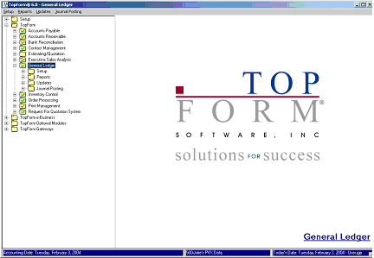

Introduction & Prerequisites

This documentation is divided into four main sections.

- Concepts and Practices
- Getting Started
- Periodic Processing
- Special Topics

Prerequisites

The General Ledger User's Guide assumes that you have familiarized yourself with the operational aspects of TopForm Accounting. By design, there are no references as to how to enter data into the system.
It is intended that the user be thoroughly familiar with the TopForm System Overview Documentation before proceeding.

Concepts and Practices

Concepts and Practices
Before getting into the details of the system, it might be helpful to investigate how information flows within the TopForm General Ledger. Once a company has been set up, there are two major processing areas, Daily and Periodic Processing (Month-end and/or Year-End).
Daily Processing

There is actually very little daily work to be done in your General Ledger System, as it receives most of its information from your other accounting applications. For example, when you enter invoices or produce checks in your Accounts Payable System, the appropriate General Ledger postings are forwarded to the General Ledger. The same is true for Accounts Receivable. When you input sales and cash receipts the General Ledger effect is recorded automatically.
The only direct entries in General Ledger are Journal Entries.

Daily Processing Involves

- Creating New General Ledger Account Numbers
- Entering and Updating Journal Entries
- Updating the Detail Transaction Register

Periodic Processing

Periodic Processing primarily consists of making any adjusting or recurring entries, printing your financial reports and then performing Period End Processing.

- Recurring Journal Entry Processing
- General Ledger System Reports - Although any of the General Ledger reports may be printed at any time, even subsequent to period end, it is common practice to print a hard copy of the financial reports and save these reports with your other accounting records.
- Period End Processing

Journal Entry
What is a Journal Entry? To answer this, let's first define a "Journal".
A Journal is a chronological listing of transactions of a similar type that prove the point of entry into the accounting system. Therefore, a Journal Entry is simply an entry into a Journal. If you were operating within the General Ledger System only, all of your transactions would be entered as direct Journal Entries. However, as TopForm is a fully integrated accounting system with other accounting applications, other journals will directly post to your General Ledger. Your only direct Journal Entries will be to record depreciation, accruals and other adjusting entries.

Below is a listing of all of the Journals that post to the General Ledger.

Module | Function | Journal | Journal Code
Accounts Receivable | Invoicing | Sales Journal | SJ
 | Cash Posting | Cash Receipts | CR
 | Assessing Finance Charges | Finance Charge | FC
Accounts Payable | Vendor Invoices | Purchases Journal | PU
 | Check Printing | Cash Disbursement | CD
 | Manual Checks/New Invoices | Manual Check Audit | MP & MC
Inventory Control | Inventory Adjustments | Inventory Transaction | IT
 | Physical Inventory | Physical Inventory | PI
General Ledger | Journal Entries | General Journal | JE
Kit Management | Kit Creation | Kit Production | KT
Bank Reconciliation | Reconciliation | Reconciliation Report | BR

Information Flow for Journal Entries

At this point, lets see how information flows within the General Ledger System.

Entering a Journal Entry

- Choose the Journal Posting Folder from the General Ledger Menu to enter your Journal Entry data.
- Choose the General Journal Entry Option and enter your journal entries.
- Choose the General Journal Report Option and print this report.
- If necessary to correct any errors or enter other journal entries, repeat the preceding steps.
- Update the General Journal.

The General Journal Update does the following:
- Creates details postings in the Daily Transaction Register File
- Clears the General Journal Entry File

The Detail Transaction Register
The Detail Transaction Register lists every posting that will subsequently be made to the General Ledger. Each posting is referenced by a Source Journal Code. Based upon the setting in the Source Journal, you have the option to summarize this information before posting to the General Ledger.

Information Flow for the Detail Transaction Register

Although it is not critical if a day is missed, the following procedure should be performed each day.

- Chose the Updates Folder from the General Ledger Menu .
- Choose the Detail Transaction Register and Update to print the report.
- Make certain that the report printed properly and review it for accuracy of the data. What exactly you should look for in this report will be covered later in this documentation.
- If necessary make any additional entries
- Reprint the report and give the update command.

Recurring Journal Entry Processing
Recurring Journal Entries can be created for routine monthly journal entries. Prior to updating, any entries requiring modification can be edited. This program helps eliminate redundant data entry while at the same time providing a checklist of the entries required for month end.

Information Flow for Recurring Journal Entries

This section of the documentation outlines the procedure for the Periodic Processing of Recurring Journal Entries.

Details regarding the creation of Recurring Journal Entries will be covered later in this documentation.

- Choose the Journal Posting Folder from the General Ledger Main Menu
- Choose the Recurring Journal and Update Option
- Print the Recurring Journal Report and review it for accuracy
- If necessary, delete any unnecessary postings and/or edit the amounts.
- Reprint the report and choose the update option.

The Recurring Journal Update does the following:

- Creates detail postings in the Daily Transaction Register File

Period End Processing
TopForm is period driven, therefore, you do not have to perform Period End Processing before you begin making entries in the new period. However, General Ledger Period End Processing should be performed as soon as possible following the completion of the following:

- All entries in your other TopForm modules have been completed for the period.
- Your Bank Reconciliation for the period has been completed and all reconciliations of your other control accounts have been verified
- Adjusting and recurring journal entries have been updated.
- Financial Reports have been printed and/or archived.

Period End Processing performs the following actions in your TopForm Accounting System.

- Cycles the accounting period.
- Based upon the general ledger parameters, period end checks to see if any general ledger postings should be removed.

Year-End Processing

Following Period End Processing for the final period in your fiscal year, the Year-End Processing programs will automatically be invoked. Year-End Processing, performs the following tasks in your TopForm Accounting System:

- Closes the current fiscal year and opens the new one.
- Transfers for each balance sheet account the ending balance for the current fiscal year to the beginning balance the new fiscal year.
- General Ledger Income and Expense accounts are combined, producing net profit or loss. This number becomes the Retained Earnings Account's beginning balance for the new fiscal year.
- For the company being closed, year-end processing retains general ledger postings and account balance summary records for as long as was specified in the General Ledger Parameters, and removes data exceeding your stated requirement.

Getting Started

General Ledger Menus
The General Ledger Main Menu consists of four main menu folders from which to select the program options.

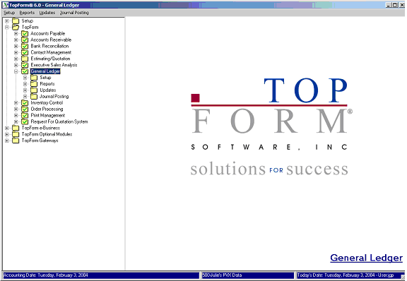

Setup Folder

This menu contains the program options, that are used when initially setting up a company. After setup, some of the options will be used occasionally, for example, when a new general ledger account is added to the system. In addition, this folder contains the Account Balance Option, where you can inquire into the period and year-to-date balance information for each account as well as establish budgets for each account and each period. We will refer to this folder as the “Main Setup Folder” to distinguish it from some of the other Setup options.

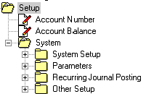

Notice that within the Setup folder, there is another folder, called System. Within this System Folder, there are four additional folders, System Setup, Parameters, Recurring Journal Posting and Other Setup. It is within these folders that you will find all the various codes that your General Ledger System will use, as well as the Recurring Journal Posting Setup Option.

Reports Folder

Use this folder to access your general ledger reports and your chart of account listing.

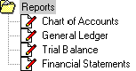

Updates Folder

The Updates Folder contains both the Details Transaction Register and Update programs along with the Period End and Year End Processing Programs.

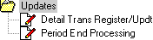

Journal Posting Folder

The Journal Posting Folder contains the General Journal Entry program as well as the General Journal (report) and Update programs. Also, the Recurring Journal (report) and update programs are found in this folder.
Note: The Recurring Journal data entry program is not located in this folder. It can be found by following this path, General Ledger/Setup/System/Recurring Journal Posting.

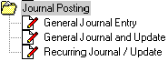

Setting Up a Company
Procedures - Overview

This section describes the steps necessary to properly set up a company for General Ledger Processing. Although this setup is typically done once, TopForm provides for multi-company accounting. If you embark upon a new venture, you may need to perform some or all of these procedures for your new company. Talk to a TopForm support representative about services available to assist you in setting up a new company.

To setup a company the following steps should be performed. More detailed information on each step is covered later in this chapter.

- Select the General Ledger option from the Main Menu, then select the Setup Folder (main Setup Folder), then select the System Folder
- From the System Folder, select the Parameters Folder, and then the G/L Parameters Option.
- Set the size and format for your general ledger account number.
- Choose the Account Number program option from the main Setup Folder and setup your chart of accounts.
- Return to the Parameters Folder and set the remainder of the parameter options. (G/L Parameters, Department Parameters, Cash Basis Options, if applicable and Financial Statement Parameters.)
- Select the Other Setup Folder and set each of options located in this folder.

At this point, all the General Ledger supporting data files will be ready for use.

The remaining steps in setting up a company are:

- Enter the General Ledger Beginning Ba1ances and Verify that the General Ledger balances to your previous accounting system*
- Optionally, enter Budget information*
- Optionally, enter Prior year information*

* See Data Conversion for more information on these setup procedures.

Setting Parameters

Parameters are used to describe to the General Ledger Programs how to enter and process data for this company. It is actually a way for a company to customize its General Ledger.

Parameters, once set, normally should not be changed. Many parameters describe how data is actually stored within the computer and changing their values could confuse the processing programs and corrupt data files.

General Ledger Codes

In addition to parameters, certain codes are required by your General Ledger System. They include:

- General Ledger Account Codes
- Department Titles
- Source Journal codes

In additional, you will need to setup your Fiscal Year and determine the Account Breaks for financial reporting.

Data Conversion

When setting up a new company, you will need the following:

- The Period ending dates for the Fiscal (Accounting) Year.
- A Chart of Accounts listing the general ledger accounts within each category
- A Trial Balance showing ending balances for the last closed accounting period. A Financial Statement will suffice, provided it does not consolidate multiple general ledger accounts onto one line.
- A Financial Statement format.

The following documents will be needed assuming you want to take immediate advantage of some optional reporting features within the TopForm General Ledger.

- Budgets by general ledger account for the Current Fiscal Year, if you want to take advantage of Budget versus Actual reporting.
- For each general ledger account, the beginning balance and the net change for each accounting period of the Prior Year, if you want to take advantage of current versus prior year reporting. You may find it more convenient to just let the system accumulate this information from this point forward.

Parameters

Parameters - General Ledger Tab
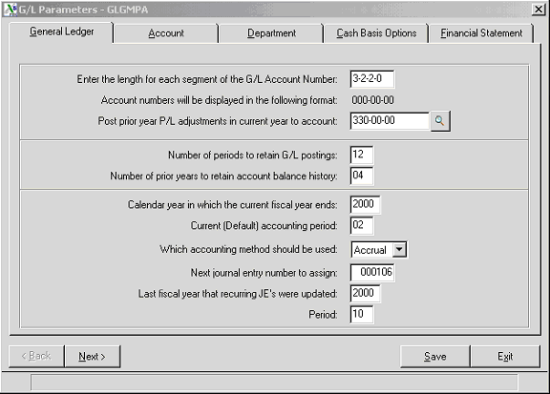

G/L Account Number Format
Specify the Length for each segment of the G/L Account Number. The Account number may be entered and displayed in up to four segments. The total number of digits cannot exceed twelve. For example:

Format | Enter As
xxx-xx | 3-2-0-0
xxxxx-x | 5-1-0-0
xxx-xxx-xxx-xxx | 3-3-3-3

Most companies will define a chart of accounts where the first segment relates to the type of account. The second segment would be used to define sub-accounts and if the company is divisional, the third segment would be used to identify the division.

Following the definition of your general ledger account format, you should probably proceed to setting up your chart of accounts as many of the remainder of the Parameters and the Other Setup programs will require you to enter General Ledger Account Numbers. You could use the setup option in each program to set up the accounts as you need them, but it is probably more efficient to get this out of the way first.

General Ledger Account Number Setup

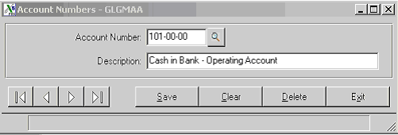

Enter each general ledger account number and the appropriate description. Note that at any point you can use the query button to see the accounts that have already been defined.

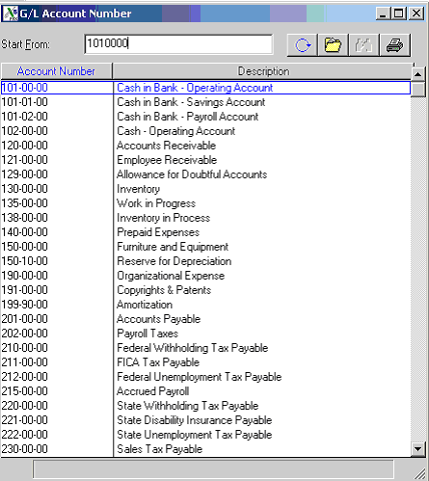

There are also two utilities found in the System / System Setup folder that enable you to copy general ledger account numbers. One of these utilities allows you to copy all or a range of account numbers from another TopForm company for which you have already setup operations. The other utility provides the ability to copy departmental accounts.

Copy Company Chart of Accounts

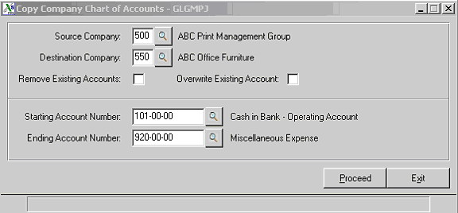

Source Company

Enter the three character company code whose chart of accounts you wish to copy.

Destination Company

Enter the three character company code for the company you are now setting up.

Remove Existing Accounts

If there is a chart of accounts already in existence for the new company, checking this box will replace it in its entirety with the new chart.

Overwrite Existing Accounts

If there is a chart of accounts already in existence for the new company, checking this box will replace only the account numbers that would otherwise be duplicated by the new entrees. Other account number will remain intact.

Starting and Ending Account Numbers

Enter the range of account numbers you wish to copy.

Copy Departmental Chart of Accounts

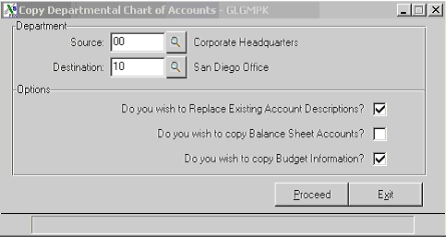

This utility allows you to set up your chart of accounts for one of your branch offices or operating divisions and then copy the account numbers to create as many other branches as you need. You can also use this utility to update the accounts in your divisions as you make changes.

Source Department

Enter the source department or branch where you have set up the prototype account numbers.

Destination Department

Enter the first new department or branch that you are creating.

Replace Existing Account Descriptions

When using this utility to update account numbers that you have changed, you can check this box to replace the existing account descriptions.

Copy Balance Sheet Accounts

Check this box to also copy Balance Sheet accounts.

Copy Budget Information

Check this box to duplicate Budget Data

Parameters – General Ledger

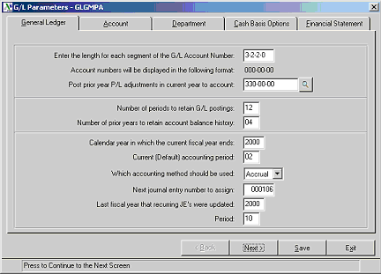

After setting up your chart of accounts, you are ready to complete the General Ledger parameters.

Prior Years Adjustments Account

The system provides for reopening a closed fiscal year. Any posting made to a closed fiscal year must be brought forward to the current fiscal year. If you make a prior year adjustment to an Income Statement Account, it must again be closed out to an account in the Equity Section. TopForm® Accounting does not assume you want this amount to be posted to Retained Earnings, and therefore, gives you the flexibility to specify an alternate account number to be posted. Enter this account in the “Post prior year P/L Adjustments in current fiscal year to account” parameter.

Periods To Retain G/L Postings

Any number of periods of general ledger postings may be retained. As disk space has become so inexpensive, set this number to the maximum that you would ever want to report or display. We suggest from 36 to 60, however it can be set as high as 99.

Account Balance History

Each General Ledger Account has an Account Balance record containing the summary totals for each of the accounting periods in the fiscal year.

Account Balance Panel

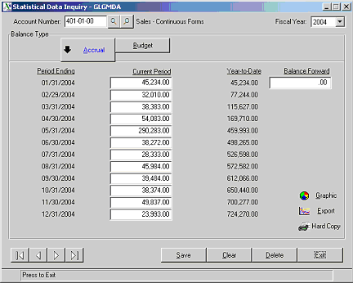

The information in this record is used to produce your financial statements. The Financial Statement program can also print comparative statements, that is, this year’s income versus the same period last year. Don't worry, if you are just going onto the system, you are not required to load this information. The system will automatically save it at year-end, giving you comparative statements starting next year. Of course, you may enter last year's information to immediately utilize this feature. To take advantage of comparative financial information, enter at least “1” for the number of prior years to retain Account Balance history. To retain more than just last year's history, enter the number of prior years history you wish to maintain instead. Once the information has been purged as a result of year-end processing, it cannot be retrieved (except from backup), therefore we recommend that you set this to three to five years.

Current Fiscal Year

Enter the Calendar Year in which the Current Fiscal Year ends. For example, if today is November 30, 2004 and the company is on a Calendar Year, enter 2004. If you were on a Fiscal Year ending June 30, enter 2005 instead. The Current Fiscal Year is used as a default in most programs.

Current Accounting Period

The Current Accounting Period is usually one more than the last closed period. Be careful if you are on a Fiscal Year. For example

Period | FYE | FYE | FYE | FYE
Ending | 12/31 | 06/30 | 10/31 | 04/30
Jan 31 | 01 | 07 | 03 | 09
Feb 28 | 02 | 08 | 04 | 10
Mar 31 | 03 | 09 | 05 | 11
Apr 30 | 04 | 10 | 06 | 12
May 31 | 05 | 11 | 07 | 01
Jun 30 | 06 | 12 | 08 | 02
Jul 31 | 07 | 01 | 09 | 03
Aug 31 | 08 | 02 | 10 | 04
Sep 30 | 09 | 03 | 11 | 05
Oct 31 | 10 | 04 | 12 | 06
Nov 30 | 11 | 05 | 01 | 07
Dec 31 | 12 | 06 | 02 | 08

The system allows for 1 to 13 accounting periods with user defined period ending dates. This information is setup later using the Fiscal Year Setup program.

Accounting Method

Enter the appropriate code for Which Accounting Method should be used. Most companies will chose “Accrual.” Later in the set up process, Cash Basis companies will be given the additional option of also reporting on a accrual basis for managerial purposes. Please note that this does add some operational complexity to your accounting system. Do not change this parameter after beginning processing

Next Journal Entry Number To Assign

TopForm provides for the system to automatically assign sequential journal entry numbers . If you have been using journal entry numbers, enter the next available number. If you have not previously used journal entry numbers, you may begin with any number, for instance, the number 000001. It is not necessary to imbed the date or the period into your numbering scheme as all transactions will have a date and an associated accounting period attached to them for inquiry.

Last Fiscal Year In Which Recurring JE’s Were Updated

This parameter helps you keep track of your Recurring Journal Entries so that you do not update them more than once within the fiscal period. Enter the period preceding when your next Recurring Journal Entry will need to be updated.

Parameters – Account Break Tab

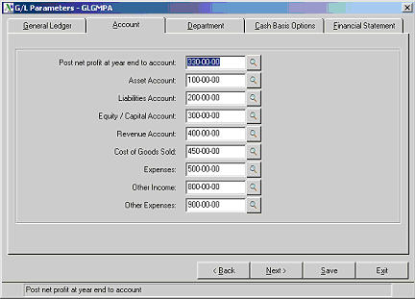

A new screen will display requesting additional parameter entries for the General Ledger
System. This panel allows you to set the main account breaks

Net Profit Account

Normally, the Retained Earnings Account Number is entered for Post Net Profit at Year End to Account

Asset Account Break

Enter the lowest possible account number to which an asset account will possibly be assigned.

Liability Account Break

Enter the lowest possible account number to which a liability account will possibly be assigned

Equity/Capital Account Break

Enter the lowest possible account number to which an equity or capital account will possibly be assigned.

Revenue Account Break

Enter the lowest possible account number to which a revenue, sales, or income account will possibly be assigned.

Cost Of Sales Account Break

Enter the lowest possible account number to which a cost of sales account will possibly be assigned.

Expense Account Break

Enter the lowest possible account number to which an expense account will possibly be assigned.

Other Income Account Break

Enter the lowest possible account number to which an other income account will possibly be assigned.

Other Expense Account Break

Enter the lowest possible account number to which an other expense account will possibly be assigned.

Parameter - Department Tab
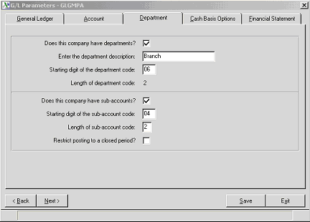

Departmental Parameter Setup Screen Definitions

Does This Company Have Departments?

To enable departmental financial reporting for this company, check this box. If you do not, the remaining questions within this section will be bypassed.

Department Description

Examples are Branch, Department, Cost Center and Division. This is for your own information, the description entered into this field will appear as the title of the field in Department Title Setup.

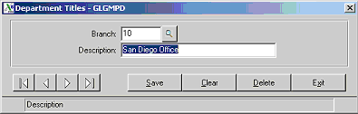

Starting Digit of Departmental Code

Financial reporting uses the starting digit in conjunction with the Length of Department Code to determine how this company's chart of accounts specifies department. For example, if the general ledger account number is structured as xxx-xx-xx and the last two digits are to be used as a department code, then you would enter 6 for the Starting Digit of the Department code. This designation is used both for printing departmental financial statements as well as establishing the parameters for general ledger substitutions.

Length Of Department Code

Financial reporting uses this code in conjunction with the starting digit to determine how this company's chart of accounts specifies department. In the previous example, you would enter 2 for the Length of Department Code. In the panel above, you can see that the department field called Branch is a two character field.
Does This Company Have Sub-Accounts
The following is an example of the use of sub-accounts:
550-00-00 - Insurance Expense
550-01-00 – Insurance Expense – General Liability
550-02-00 – Insurance Expense – Workers Compensation
550-03-00 – Insurance Expense – Life and Medical
Here 550 is the segment of the account number that defines Insurance. The second segment further classifies transactions as to the type of insurance.
If you check the box, “Does this Company have Sub-Accounts”, you will need to define the segment of the account number that relates to the sub-account. In the above insurance example, you would answer the two questions as follows:
Starting Digit Of The Sub-Account Code?
The answer would be 04. The sub-account starts in the fourth position of the account number.
Length of The Sub-Account Code?
The answer would be 2, as the sub-account has two digits.
Restrict Posting To A Closed Period?
To restrict postings to a closed period, you would need to answer this question, “Y”. However, you may wish to allow certain personnel to post to a closed period. You can accomplish this selective authorization through the “Application Security by Operator” option on System Access and Security Option in TopForm.

Parameters - Cash Basis Options Tab
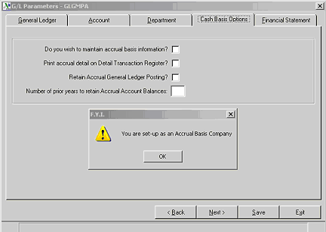

For Cash Basis companies, TopForm Accounting has a unique feature. Automatically, it can retain a second set of books on the Accrual Method! This provides a Cash Basis company with invaluable management information prior to bills being paid and cash being received. One word of caution, maintaining two sets of books will add a certain amount of complexity to your accounting system. When making journal entries, you will have to decide whether the journal entry should effect the Cash Basis books, the Accrual Basis books or both. And, your Detail Transaction Registers will be include both sets of postings.

Do you wish to maintain accrual basis information?

If you are a Cash Basis Company, to exercise the option of also maintaining accrual basis books, check this box. Checking this box enables this feature not only in the General Ledger Module, but in other modules, such as Accounts Payable and Accounts Receivable, which are integrated into the General Ledger.
Note that this only applies to cash basis companies. If you tax reporting is on the accrual basis, there would be no advantage to also maintaining cash basis books. If you choose this tab and your are an Accrual Basis Company, the above message will appear.

Print accrual detail on the Detail Transaction Register?

The general ledger postings for the accrual entries on cash basis companies can optionally be printed on the Detail Transaction Register. Of course, your cash basis transactions will always be printed. The Detail Transaction Register details all general ledger transactions by source journal prior to posting the General Ledger files. Since the accrual postings are for reference, it is appropriate to extend you this option.

Maintain Accrual Basis General Ledger Postings?

Cash basis companies may elect not to retain the accrual general ledger posting detail. In this case, the General Ledger report for the accrual books would be unavailable. In either case, the Account balance summary records, which accumulate totals by accounting period, will be retained for use by financial statement printing. We recommend that you check this box so that you will have an audit of your accrual basis postings. Otherwise you would just be able to print financial statements without any supporting detail

Number of prior years to maintain accrual balances?

We recommend that you set this parameter to a minimum of one year.

Parameters - Financial Statement Tab
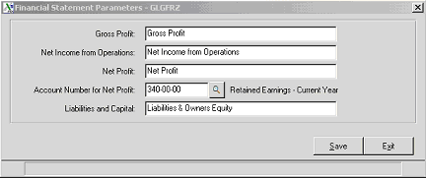

Some of the headings within the Financial Statements can be modified to suit each company’s specific requirements.

Gross Profit
Enter the description for the Gross Profit line on the lncome Statement.
Net Income from Operations
Enter the description you want to use for Net Income from Operations on the Income Statement.
Net Profit
Enter the Income Statement description you wish to use for Net Profit
G/L Account For Net Profit
Enter the account number you plan to use for Net Profit on the Balance Sheet. This is normally found in the Equity or Capital section of your Chart of Accounts. Usually, this account number is not posted since the year to date Net Income on the Income Statement calculates its balance.
Liabilities & Capital
Enter the Balance Sheet description you wish to use for Liabilities & Capital. Liabilities and Owners Equity is another example.

General Ledger Setup

Department Title Setup Screen

This program is used to define the valid departments or branches within the general ledger system. The length of the Department field was defined in your General Ledger Parameters, Department Panel as two characters. The department field title of “Branch” was defined there as well. Set up one department for each of your branch offices or operating divisions. If you did not check the “Do you have Departments?” box, you will not be able to access this panel.

Fiscal Year Setup Screen
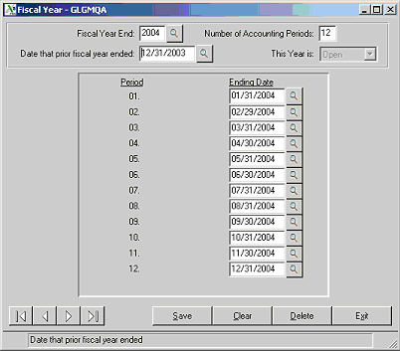

In addition to setting up an entry for the Current Fiscal Year, be sure to set up entries for prior Fiscal Year(s) for which you plan to enter information.

Since information is stored internally within the General Ledger System by accounting period within fiscal year, this information cannot be easily changed once postings have been made. Do not Proceed if you are unsure of the information required by this screen. Check with your accounting advisor.

Should you have a fiscal year change subsequent to beginning operations, TopForm can assist in running our Fiscal Year Change utility programs.

Fiscal Year Setup Screen Definitions

Fiscal Year End

Enter the full four digit year, for example, 2004.

Number of Accounting Periods

Usually this entry is twelve for twelve monthly periods. However, a fiscal year can have from one (1) to thirteen (13) accounting periods.

Date that Prior Fiscal Year Ended

This date is used to determine the beginning date for the first accounting period.

Accounting Period Ending Dates

This information will default for standard calendar month periods. If your periods end on some other day, be certain to specify the period ending date for each period. Also, don't forget that February has 29 days in a leap year!

G/L Account Break Setup Screen
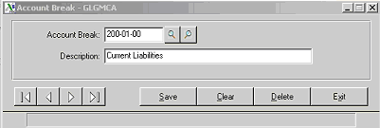

The General Ledger Parameters previously discussed contain the Major Account Breaks that generate totals on the financial statements. This program is used to setup additional subtotals to print on the Financial Statements.

Enter the lowest account number to include in this section of your financial statements and then enter the heading that should print before the section as well as along side the total lines.

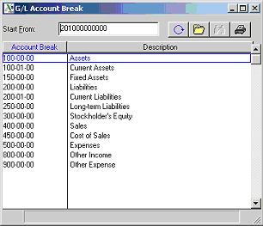

You can use your right query button to see of list of the account breaks you have set up so far (see illustration above). The breaks shown in this query are fairly typical of account breaks you might want.

Source Journal Code Setup
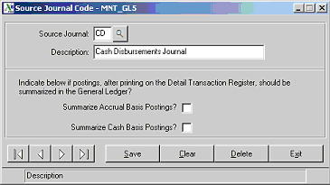

The General Ledger System comes setup with the most used Journal Posting Codes. See the table below for a list of codes and their descriptions. Note that the Source Journal that are in Bold are those that would be entered via General Journal Entry. You can create multiple codes to use when entering Journal Entries so that you can track the different types of entries.

Code | Journal Description
CD | Cash Disbursement Journal
CR | Cash Receipts Journal
FC | Finance Charge Journal
IT | Inventory Transaction Journal
JE | General Journal
MC | Manual Check Disbursements Journal
MP | Manual Check Purchases Journal
P1 | Physical Inventory Journal
PR | Payroll Journal
PU | Purchases Journal
SJ | Sales Journal

To setup additional Source Journal Codes, simply enter the code followed by its description.

Each Detail Transaction Register that prints, shows every posting that can be subsequently made to the General Ledger sequenced by Source Journal Code. You have the option to summarize this information before posting to the General Ledger by checking the appropriate box. For example, normally, the Finance Charge Journal would be summary posted, that is, you would not want to see each individual charge in your general ledger. However, your purchases journal would be detail posted because you would want to see each vendor code, name and invoice details in your appropriate expense accounts.
Entering Budgets

Choose the Account Balance Option from the General Ledger Main Setup Folder. Enter in the first account number for which you want to enter budget data. Click on the Budget button. Enter the budget amount for period one and press the enter key.

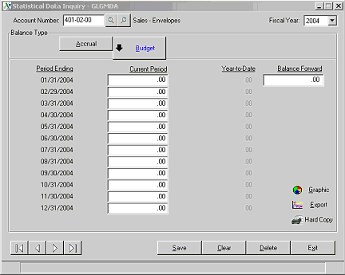

You will be given the option to repeat this entry for all twelve periods. If more than half of the entries are the same, click the “Yes” button.

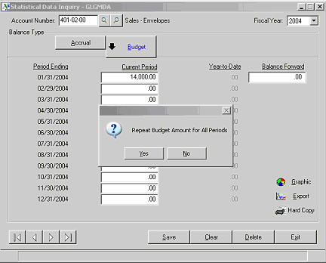

Account Balance Setup and Inquiry
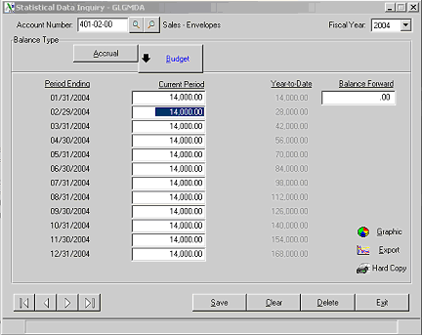

If not, click “No” and enter each period’s budget individually. You can then click into the periods that may need modification.

Or you can click “No” and enter each period’s budget data. Notice that the year to date numbers update.

Compare the year to date total, with your source document before you move on to the next general ledger account.
To advance to the next general ledger account, simply click on the forward arrow.

Account Balance Setup and Inquiry

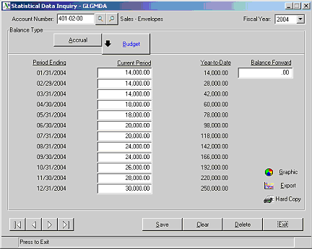

Notice that your have three additional options on this panel.



Graphic | Click on this button to see a graphic representation of the numbers
Export | Click on this button to export this data into an Excel Spreadsheet.
Hard Copy | Click on this button to print a hard copy of this data.

Account Balance Graphic
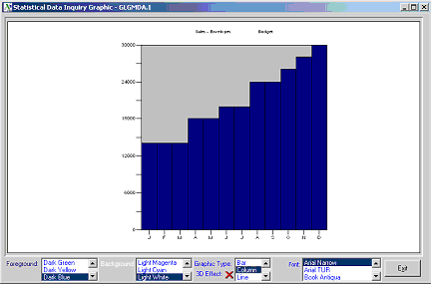

Once positioned on the Graphic Panel, you can choose the Foreground color, the Background color, the type of graph and the font color. Use the arrows to scroll through the choice and click to see the results.

Hard Copy Option
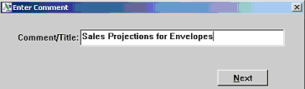

You will be presented with a screen in which you can type a description or title before printing a hard copy.

Daily and Periodic Processes

General Ledger Journal Entry
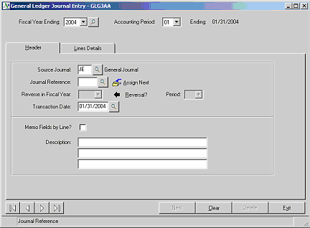

Choose the Journal Entry option from the Journal Posting folder.

Fiscal Year and Accounting Period

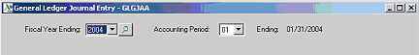

One of the most important selections in an accounting entry is the fiscal year and accounting period. This controls the period in which the posting will be made, regardless of the transaction date. Note that the fiscal year and accounting period make up part of the key to the record. Therefore, it cannot be changed. To correct an error, you must delete the entry and re-enter it from scratch, so pay attention to this very important component of every entry.



Enter the Source Journal. You can use the query button to look up the available options. You should not choose any source journal code that belongs to another TopForm m module.

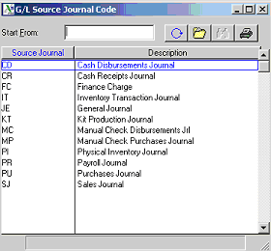

The only two appropriate choices from this list would be JE for Journal Entry and PR for Payroll Entry. Since TopForm does not have a Payroll module you will probably use Journal Entries to record your payroll entries

General Ledger Journal Entry

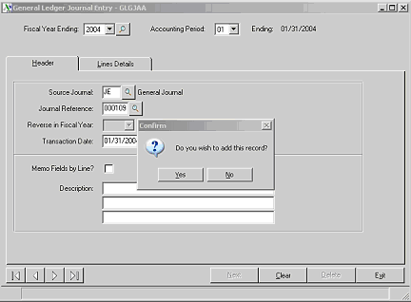

Click the “Assign Next” button to assign the next Journal Entry Number. The prompt appears to require you to confirm that you wish to add this record. Click Yes.

Automatic Reversal Entries

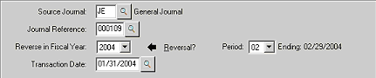

TopForm provides you with the ability to automatically reverse certain entries. As a part of your month end reconciliations, you might find that inventory has arrived in the warehouse, but the vendor invoice has not yet arrived. You therefore have more inventory that your general ledger reflects and you have an obligation to a vendor that has not yet been entered into accounts payable. To properly state inventory and liabilities, you should make the following entry:

Dr Cr
Inventory XXX
Accrued Payables XXX

However, next month, the vendor invoices will arrive. You don’t want to have to treat these vendor invoices any differently than any of the others that are being entered. However, if your operators post these vendor invoices to inventory, your inventory account will be overstated. Therefore, you would set your journal entry to automatically reverse. This allows you to properly state your financials at month end, but eliminates any special processing requirement on these entries.

To set an entry to automatically reverse, simply click on the “Reversal” arrow. You will then be able to enter the year and accounting period to reverse this entry. This will almost always be the period immediately following the fiscal year and accounting period of the original entry.

Description

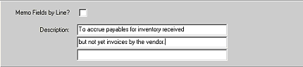

You have three lines of description that you can attach to any journal entry. When viewing or printing your general ledger report, you can elect to have the extending description display.

General Ledger Lines
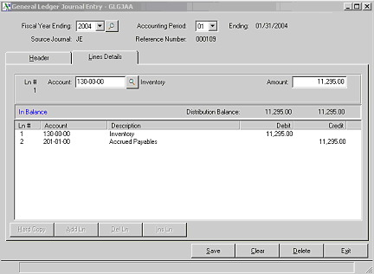

Note: Adding, deleting and modifying lines are common routines in all of the data entry programs involving general ledger postings. Once you familiarize yourself with these routines, you will be proficient in the other programs as well.

You can click on any line to make it the active line.

General Ledger Journal Entry Lines
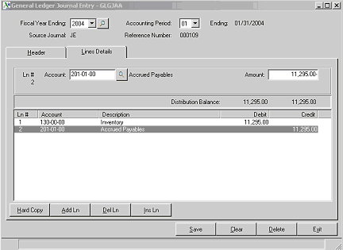

- You can then click then delete line button to delete the active line.
- Or you can modify the general ledger account or the amount or
- You can click on the Insert Line button to insert a new line above the line selected. See the illustration below.

By clicking on a line, then clicking on the Insert line button, you open a space to insert a new general ledger posting.

Note that the debit and the credit totals of the Distribution balance must equal to be able to exit from the general ledger lines entry portion of this program. Once the entry is in balance, you have the option the run and update the General Ledger Journal.

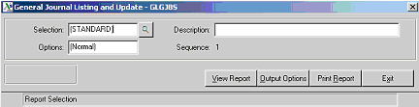

General Ledger Journal Update
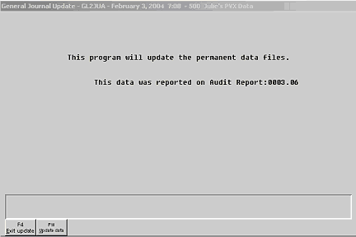

The above message will appear. Note that the audit report number is this example is 0003.06. This means that it is the third general journal, and the sixth printing. (The number preceding the decimal represents the actual journal number and the number following the decimal represents the number of times the report has been printed.)

This number will update to the general ledger so that you can trace back the entry to the journal entry report of which it was a part.

If you press the F10 key or click the “Update data” button, the entries will post to the general ledger. If you click the F4 key or click the “Exit Update” button, the entries will not update until you again run this journal report and click the “Update data” button.

Recurring Journal Entry Setup Panel
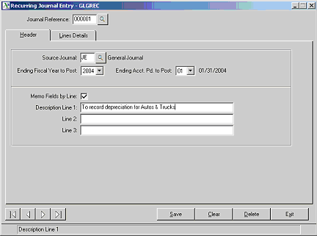

Recurring Journal Entry is very similar to regular journal entries. The following are some differences:

- You do not have a reversal option
- There is no automatic numbering.
- There are two additional fields to enter the last fiscal year and accounting period to post. If you were using the recurring journal program to record insurance expense each month with the credit going to prepaid insurance, you would enter the last period that the pre-payment covered. This prevents you from accidentally making journal entries that no longer are appropriate.

You do have the Memo field by line item, as you do in regular journal entries. We will use the Recurring Journal Entry Program to describe this feature.

Click on the Memo Fields by Line box to trigger this feature. You can still enter up to three line of description as you could on any journal entry.

Recurring Journal Entries Lines Entr
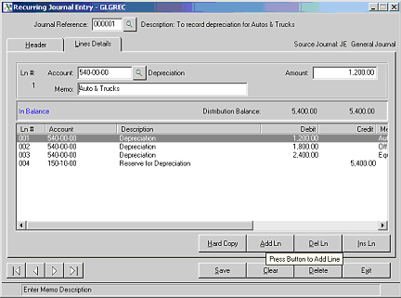

Notice that you can enter a Memo for each line of your general ledger posting. In this example, we have entered a depreciation journal entry and have entered a memo line to specify which assets the journal entries affect. You can use the scroll bar to see that the line item memos indicate that the depreciation is for Autos and Truck, Office Furniture and Equipment.

Recurring Journal Entry Listing
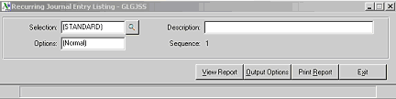

At any point in time you can run the Recurring Journal Entry Listing to see the details of the recurring journal entries that are still active. This is just a listing report.

Recurring Journal Update
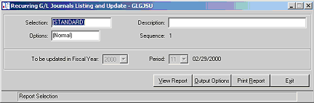

To update the recurring journal entries, chose the Recurring G/L Journals Listing and Update option from the Journal Posting folder. Following viewing or printing this listing, you will be presented with an update option.

Detail Transaction Register/Update
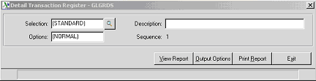

Each day you should print and update this report. Prior to the update, you should check the report as follows:

- Look at the totals on the report. The debits and credits should equal.
- Look at the fiscal year and accounting period at the very top of the report and at the bottom. Make certain that no postings were made to an out of date period.
- Look at the very top of the report and make certain that no posting were made to a not-on-file account (000-00-00 depending upon you account format).
- All these are indications that something has gone wrong and requires your attention.
- TopForm requires all entries to be in balance. If the debits and credit do not equal, something has gone wrong. You have either had an interruption in an update (most likely) or a programming issue.
- Solution: Find the individual source journal listed on the report that is out of balance. By reviewing the details within the out of balance source journal, you should be able to determine what your journal entry will need to be to correct the out of balance situation. Since you are out of balance, you will be required to make a one-side journal entry to put you back in balance. Typically, only your Accounting Manager or System Administration will have to code to instruct TopForm to accept a one sided journal entry.
- Once you make the one-sided journal entry, you should rerun the Detail Transaction Register. It should now be in balance and you will be permitted to update.
- TopForm will default the earliest unclosed period on each accounting transaction. There may be times when you have not closed your month but are making posting in the new period. In this event you should override the default fiscal year and accounting period with the correct setting for your entry. Your operator may have failed to do this, or otherwise entered the wrong period. This should be obvious on your Detail Transaction Register as this report lists all of the transactions in order by the period and fiscal year. Look at the beginning of the report and at the end.
- Solution: As the fiscal year and accounting period are part of the key to the record, you will need to reverse and re-enter this transaction.
- If you have a posting to a “000” account, you have a general ledger interface problem. You may have deleted a general ledger account that is still set up in one of your interface programs.

Solution: Make a journal entry to debit or credit the correct account(s) with the opposing entry to the “000” account.
All of these problems are relatively easy to resolve if caught early (at the time of the detail transaction register). So look out for them.

General Ledger Reporting

The Chart of Accounts Listing
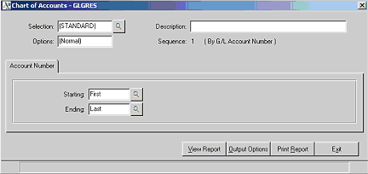

This report list all or a range of the general ledger account numbers. It is rarely used since lookup is available throughout the TopForm system.

TopForm General Ledger
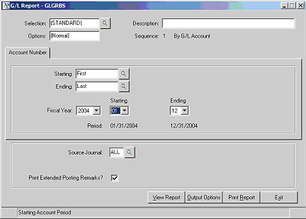

The TopForm General Ledger prints or displays the general ledger accounts along with the detail postings for each. You have the option to print all or a range of accounts. You can also specify that the report print a single period or a range of periods for the fiscal year. You can print all entries or restrict the entries to only those associated with a specific source journal or a specific audit report.

Since you have to option to print or display this data at any time, you may just choose to view the data when you have a need to analyze an account. Make certain that your parameter options are set so that the detail general ledger postings are kept for as many periods and years as you wish to view the date.

It is probably a good idea to print and save or archive this report at least at year end.

TopForm General Ledger Trial Balance
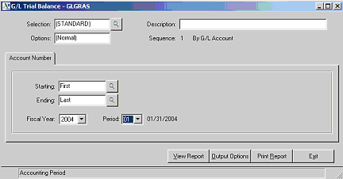

TopForm General Ledger Financial Statements
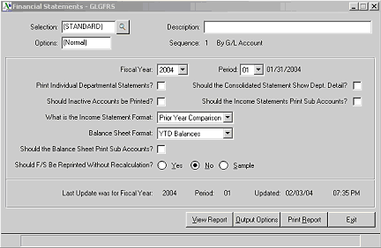

There are two basic financial reports that you can print from your TopForm General Ledger:

- Balance Sheet
- Profit and Loss or Income Statement

You also have several options when printing these reports. With regard to the Balance Sheet, you can print a standard balance sheet, or you can print a prior year comparison.

With regard to the Profit and Loss Statement you have three options.

- Month to Date and Year to Date
- Prior Year Comparison
- Budget Actual Comparison

Period End
Period End Processing

When you choose Period End Processing, the current period and year will display. Review this data and make certain that it displays what you expect.
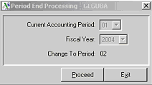
Once you click on the Proceed button, you will be presenting with additional information.
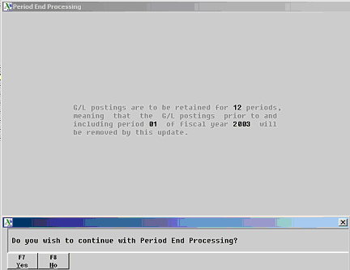
This panel restates what has been identified as your preferences in you General Ledger Parameters. In the above example, it states that you have elected to retain general ledger postings for twelve periods . It also displays the period and fiscal year postings that will be removed during this period end update. If this is not what you intended, click the “No” button and choose the general ledger parameter option from the Setup/System Folder and extend the length of time that general ledger postings should be retained.

Remember, disk space is usually not a problem. It is better to have more data than not enough.

Special Topics

What Is Data Conversion?
Data Conversion is the process of moving dat from your existing computer or manual system to the system new computerized system being implemented. Under most circumstances, at least part of this will be done through automated means. Proper planning is a prerequisite for a smooth transition.

The necessary steps for data conversion of your general ledger data are:

- Setting up the Chart of Accounts
- Entering the Account Balances
- Verification of the Balances

Additionally, you may elect to:

- Enter prior period activity for the current and preceding year. This allows you to take immediate advantage of comparative financial statements.
- Enter budget amounts for prior and future periods in order to facilitate budget variance financial reporting.

Be sure to gather all your records before you begin the conversion process.

Read this entire section before you begin processing. If you are attempting the conversion process for the first time, refer to the Getting Started and the Daily and Periodic Processing sections of this documentation to gain a thorough understanding of the operation of the General Ledger system.

Chart of Accounts
Refer to the Accounting Theorv section for a discussion on Account Number Structure and Ordering the Chart

Account Number Setup Screen
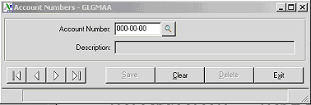

Enter each account number and a description for the account.

Account Balance Conversion
Normally one of two procedures is followed when converting the account balances. They have to do with where you are within your accounting year.

Recent Year End - Beginning Balances Available
If your fiscal or accounting year-end has just recently passed, you may want to convert as of your prior fiscal year end. For instance, if you were implementing the system in October or November, and your fiscal year ended September 30, it might be advantageous to capture the transactions on at least a summary basis starting October 1.

The procedure to accomplish this would be:

- Enter the year ending balances as of September 30 for your Balance Sheet Accounts. It would not be necessary to enter balances for the Income and Expense Accounts, since they are closed at year end to retained earnings.
- Select the General Ledger Parameter Setup to set the Fiscal Year and Accounting Period to the year and period for which you are beginning the conversion.
- If you have not already done so, using the Fiscal Year Setup Program, set up any prior fiscal year records for which you will be entering information.
- Select the Journal Entry program.
- Be sure the Fiscal Year and Accounting Period are properly set. If the program does not accept the Fiscal Year, chances are the prior fiscal year record is not set up.
- Use a "JE" Source Journal Code.
- Enter "Ending Balance Conversion" for the Description.
- Enter the account number and ending balance for all non-zero balance sheet accounts. (Be certain to enter a minus sign before or after the amount when entering credit balances.) Don’t forget to include your year-to-date net income in your Retained Earnings Account.
- Print the General Journal, verify it, and update

Print the Detail Transaction Register and Update.

Print a Financial Statement for the period and review for accuracy. Remember, Assets must equal Liabilities and Owners Equity.

- Select Period End Processing so that the ending balances will be brought forward as beginning balances for the new year.
- Enter summary postings for activity since the year end using the Journal Entry program. Or, if feasible, enter the actual transaction within the Accounts Receivable or Accounts Payable System. (Refer to the conversion section on each application before using that application.)

This method would allow you to have a General Ledger with correct balances for each accounting period within the current fiscal year.

Beginning Balances Unavailable
You are not required to have your beginning balances in place prior to beginning processing. They can be entered when they become available. This is often the case when outside firms prepare periodic financial statements.

Do not let too much time pass as…..

You will not have meaningful Financial Statements until these balances are entered.
Reconciliation becomes increasingly more difficult as time passes.

Late In The Fiscal Year
If you are well into your accounting year, it is usually not advisable to go too far back in time for a conversion., unless this conversion can be done through automated means. Such an effort usually places great strains on the operator to “catch up", and leads to errors and frustration. If you are well into your fiscal year and your are converting manually,

- Begin your conversion as of the last day of the preceding closed period by entering the ending balances for each General Ledger Account using the Journal Entry Program. Follow the procedural steps outlined previously; except, under these circumstances, be sure to enter balances for your Income and Expense Accounts as well.
- Period End Processing in this case will just advance the period to the current accounting period.

Verification
Immediately after entering the beginning balances, print a Trial Balance for the last closed accounting period. Compare this report to the source document from which the balances were converted. Using the Journal Entry Program, make any necessary changes before proceeding. Retain this report as well as all period end reports to properly document the accounting system.

Historical Balances
If you wish to immediately take advantage of the comparative Financial Statement features, you will need to enter account activity for each period of the current and preceding years(s).

To illustrate the first method, lets assume the following:

- Calendar Year Accounting
- Current accounting date is March 1, 2004
- Comparative Financial Statements desired for 2003 and 2004

Perform the following steps:

Using the General Ledger Parameter Setup Program, set the Fiscal Year to 2002, and the Current Accounting Period to 12.

Be sure you have set up 2002, 2003 and 2004 in the Fiscal Year Setup program.

- Using the Journal Entry Program, enter ending balances as of December 31, 2002. Remember, you only need to enter balances for Balance Sheet accounts.
- Perform Period End Processing in order to close the year and bring the balances forward as beginning balances for January, 1, 2003
- Select the Journal Entry Program and post the net activity for January, 2003. Do not post the January ending balances but the net change for the period. After printing and updating both the General Journal and the Detail Transaction Postings, select Period End Processing to advance the accounting period. Repeat this step for February through December, 1003. Period end for December will also perform year-end and advance the system to period 1 of 2004.
- Repeat the preceding step for January and February, 2004.

Verify that the activity and balances are correct by producing a trial balance and comparing it to the trial balance or financial statement from which you were converting.

Budgets
The Financial Statement printing program provides an option to print budgets. In order to take advantage of this feature, it is necessary to set up budgets for the general ledger accounts.

Account Balance Setup
The Account Balance Setup Program is used to enter budget information as well as to provide inquiry into a general ledger account balances. To enter budget information,
choose the Account Balance Option from the General Ledger Main Setup Folder. Enter in the first account number for which you want to enter budget data. Click on the Budget button. Enter the budget amount for period one and press the enter key.

You will be given the option to repeat this entry for all twelve periods. If more than half of the entries are the same, click the “Yes” button.

Account Balance Setup and Inquiry

If not, click “No” and enter each period’s budget individually. You can then click into the periods that may need modification.

Or you can click “No” and enter each period’s budget data. Notice that the year to date numbers update. Compare the year to date total, with your source document before you move on to the next general ledger account.

To advance to the next general ledger account, simply click on the forward arrow.

Index

1
12
Current Accounting Period 70
2
2002
Fiscal Year 70
A
Accept
Fiscal Year 65
Accept 65
Account 14
Account Balance
Entering 61
Account Balance 14, 61
Account Balance Conversion 64
Account Balance Graphic 38
Account Balance History 14
Account Balance Option
choose 33, 72
contains 9
Account Balance Option 9, 33, 72
Account Balance Panel 14
Account Balance Setup 72, 74
Account Balance Setup Program 72
Account Break Tab 22
Account Breaks
determine 12
Account Breaks 12
Account Number
Choose 12
Account Number 12
Account Number Setup Screen 63
Account Number Structure 62
Accounting Manager 53
Accounting Period
Number 30
Accounting Period 30, 41, 65
Accounting Theorv
Refer 62
Accounting Theorv 62
Accounts
Chart 12, 28, 61, 62
Copy Company Chart 14
Copy Departmental Chart 14
Current Fiscal Year 12
Method 14
Period Ending Dates 30
Year End 22
Accounts 12, 14, 22, 26, 28, 30, 61, 62
Accounts Listing
Chart 55
Accounts Listing 55
Accounts Payable 4, 26
Accounts Payable System 3, 65
Accounts Receivable 3, 4, 26, 65
Accrual Basis 26
Accrual Basis Company 26
Accrual Method 26
Accrual. 14
Accrued Payables XXX 41
Actual 12
Although 3
And/or 7, 8
Application Security 24
Apr 30 14
As… 67
Assessing
Finance Charges 4
Assessing 4
Asset Account Break 22
Assign Next 41
Aug 31 14
Automatic Reversal Entries 41
Autos 50
B
Background 38
Balance Sheet
balances 70
Enter 28
Net Profit 28
regard 58
Balance Sheet 14, 28, 58, 70
Balance Sheet Accounts 65
Balances
Balance Sheet 70
Income 65
Balances 61, 65, 70
Balances Unavailable
Beginning 67
Balances Unavailable 67
Bank Reconciliation 4, 8
Becomes
Retained Earnings Account's 8
Becomes 8
Beginning
Balances Unavailable 67
Beginning 67
Beginning Balances Available 65
Bold 33
BR 4
Branch 29
Branch 24
Budget Actual Comparison 58
Budget button 33, 72
Budget Data 14
Budgets
Entering 33
Budgets 12, 33, 71
C
Calendar Year
Enter 14
Calendar Year 14
Calendar Year Accounting 70
Capital 28
Cash Basis
effect 26
provides 26
Cash Basis 14, 26
Cash Basis Company 26
Cash Basis Options 12
Cash Basis Options Tab 26
Cash Disbursement 4
Cash Disbursement Journal 33
Cash Posting 4
Cash Receipts 4
Cash Receipts Journal 33
CD 4, 33
Chart
Accounts 12, 28, 61, 62
Accounts Listing 55
Ordering 62
Chart 12, 28, 55, 61, 62
Check Printing 4
Choose
Account Balance Option 33, 72
Account Number 12
Detail Transaction Register 6
Foreground 38
General Journal Entry Option 4
General Journal Report Option 4
Journal Entry 41
Journal Posting Folder 4, 7
Recurring Journal 7
Choose 4, 6, 7, 12, 33, 38, 41, 72
Clears
General Journal Entry File 4
Clears 4
Clicking
Insert 46
Clicking 46
Closed Period
Restrict Posting To 24
Closed Period 24
Company 12, 24
Company’s 28
Comparative Financial Statements 70
Concepts 3
Contains
Account Balance Option 9
Major Account Breaks 32
Contains 9, 32
Copy Balance Sheet Accounts 14
Copy Budget Information 14
Copy Company Chart
Accounts 14
Copy Company Chart 14
Copy Departmental Chart
Accounts 14
Copy Departmental Chart 14
Cost Center 24
Cost Of Sales Account Break 22
CR 4, 33
Creating
New General Ledger Account Numbers 3
Creating 3
Current Accounting Period
12 70
Current Accounting Period 14, 70
Current Fiscal Year
account 12
Current Fiscal Year 12, 14, 30
D
Daily 3, 61
Daily Processing 3
Daily Processing Involves 3
Daily Transaction Register File 4, 7
Dat
moving 61
Dat 61
Data Conversion 12, 61
Date
Year 58
Date 58
Dec 31 14
December
end 70
December 70
December 31 70
Department
Starting Digit 24
Department 24, 29
Department Code
Length 24
Department Code 24
Department Description 24
Department Panel 29
Department Parameters 12
Department Tab 24
Department Title Setup 24
Department Title Setup Screen 29
Department Titles 12
Departmental Code 24
Departmental Parameter Setup Screen Definitions 24
Departments? 29
Describe
General Ledger Programs 12
Describe 12
Description 65
Destination Company 14
Destination Department 14
Detail Transaction Postings 70
Detail Transaction Register
Choose 6
Information Flow 6
Print 65
Detail Transaction Register 6, 9, 26, 33, 53, 65
Detail Transaction Register/Update 53
Determine
Account Breaks 12
Determine 12
Digit
Starting 24
Digit 24
Digit Of The Sub-Account Code
Starting 24
Digit Of The Sub-Account Code 24
Distribution
totals 46
Distribution 46
Division 24
Does 24
Does This Company Have Departments 24
Does This Company Have Sub-Accounts 24
Don’t 41, 65
Dr Cr 41
E
Effect
Cash Basis 26
Effect 26
End
December 70
End 70
Ending Account Numbers 14
Enter 65
Enter As 14
Entering
Account Balances 61
Balance Sheet 28
Budgets 33
Calendar Year 14
General Ledger Beginning Ba1ances 12
Income Statement 28
Journal Entries 33
Journal Entry 4
Memo 50
Post Net Profit 22
Source Journal 41
Entering 4, 12, 14, 22, 28, 33, 41, 50, 61
Equipment 50
Equity 28
Equity Section 14
Equity/Capital Account Break 22
Excel Spreadsheet 36
Exit Update 48
Expense 8
Expense Account Break 22
Expense Accounts 65, 68
F
F10 key
press 48
F10 key 48
F4 key 48
FC 4, 33
Feb 28 14
February 30, 70
Finance Charge Journal 33
Finance Charges
Assessing 4
Finance Charges 4
Financial Reports 8
Financial Statement
Print 65
Financial Statement 12, 14, 28, 32, 65, 67, 70, 71
Financial Statement Parameters 12
Financial Statement Tab 28
Financials 41
Fiscal 12
Fiscal Year
2002 70
accept 65
set 65
Fiscal Year 12, 14, 30, 41, 65, 70
Fiscal Year Change 30
Fiscal Year End 30
Fiscal Year Setup 14, 70
Fiscal Year Setup Program 65
Fiscal Year Setup Screen 30
Fiscal Year Setup Screen Definitions 30
Following
Period End Processing 8
Following 8
Foreground
choose 38
Foreground 38
Forwarded
General Ledger 3
Forwarded 3
FYE 14
G
G/L Account Break Setup Screen 32
G/L Account For Net Profit 28
G/L Account Number
segment 14
G/L Account Number 14
G/L Account Number Format 14
G/L Parameters 12
G/L Parameters Option 12
General Journal
Print 65
General Journal 4, 9, 33, 65, 70
General Journal Entry 9, 33
General Journal Entry File
Clears 4
General Journal Entry File 4
General Journal Entry Option
Choose 4
General Journal Entry Option 4
General Journal Report Option
Choose 4
General Journal Report Option 4
General Journal Update 4
General Ledger
forwarded 3
post 4, 6, 26
posting 33
Select 12
General Ledger 1, 3, 4, 6, 12, 14, 22, 26, 33, 61, 65
General Ledger Account 14, 68
General Ledger Account Codes 12
General Ledger Account Number Setup 14
General Ledger Account Numbers 14
General Ledger Beginning Ba1ances
Enter 12
General Ledger Beginning Ba1ances 12
General Ledger Codes 12
General Ledger Income 8
General Ledger Journal 46
General Ledger Journal Entry 41
General Ledger Journal Entry Lines 46
General Ledger Journal Update 48
General Ledger Lines 41
General Ledger Main Menu 7, 9
General Ledger Main Setup Folder 33, 72
General Ledger Menu 4, 6, 9
General Ledger Module 26
General Ledger Parameter Setup
Select 65
General Ledger Parameter Setup 65
General Ledger Parameter Setup Program 70
General Ledger Parameters 8, 29, 32, 59
General Ledger Processing 12
General Ledger Programs
describe 12
General Ledger Programs 12
General Ledger System 3, 4, 9, 12, 30, 33
General Ledger System Reports 3
General Ledger Tab 14
General Ledger User's Guide 1
General Ledger/Setup/System/Recurring Journal Posting 9
General Liability 24
Getting
Started 1
Getting 1
Getting Started
refer 61
Getting Started 61
Graphic Panel 38
Gross Profit 28
H
Hard Copy 36
Hard Copy Option 39
Historical Balances 70
However, General Ledger Period End Processing 8
I
Income
balances 65
Income 65, 68
Income Statement
Enter 28
Net Income 28
Operations 28
Income Statement 28, 58
Income Statement Account 14
Information Flow
Detail Transaction Register 6
Journal Entries 4
Recurring Journal Entries 7
Information Flow 4, 6, 7
Inquiry 74
Insert
clicking 46
Insert 46
Insert Line button 46
Insurance 24
Insurance Expense 24
Introduction & Prerequisites 1
Inventory Adjustments 4
Inventory Control 4
Inventory Transaction 4
Inventory Transaction Journal 33
Inventory XXX 41
Is Data Conversion 61
IT 4, 33
J
Jan 31 14
January
post 70
January 70
JE
Journal Entry 41
JE 4, 33, 41, 65
Journal 4
Journal Code 4
Journal Description 33
Journal Entries
Choose 41
entering 4, 33
Information Flow 4
JE 41
Recurring 7, 49
Select 65
Journal Entries 3, 4, 7, 33, 41, 49, 65
Journal Entries Lines Entr
Recurring 50
Journal Entries Lines Entr 50
Journal Entry Listing
Recurring 51
Journal Entry Listing 51
Journal Entry Number 41
Journal Entry Processing
Recurring 7
Journal Entry Processing 7
Journal Entry Program
Select 70
Journal Entry Program 68, 69, 70
Journal Entry Setup Panel
Recurring 49
Journal Entry Setup Panel 49
Journal Posting 41, 52
Journal Posting Codes 33
Journal Posting Folder
Choose 4, 7
Journal Posting Folder 4, 7, 9
Journal Update
Recurring 52
Journal Update 52
Jul 31 14
Jun 30 14
June 30 14
K
Kit Creation 4
Kit Management 4
Kit Production 4
KT 4
L
Last Fiscal Year In Which Recurring JE’s Were Updated 14
Late In The Fiscal Year 68
Length
Department Code 24
Specify 14
Length 14, 24
Length Of Department Code 24
Liabilities 28, 65
Liabilities & Capital 28
Liability Account Break 22
Life 24
Line 49
Lncome Statement 28
Loss 58
Loss Statement 58
M
Main Menu 12
Main Setup Folder 9
Maintain Accrual Basis General Ledger Postings 26
Major Account Breaks
contain 32
Major Account Breaks 32
Manual Check Audit 4
Manual Check Disbursements Journal 33
Manual Check Purchases Journal 33
Manual Checks/New Invoices 4
March 70
MC 4, 33
Medical 24
Memo
enter 50
Memo 49, 50
Memo Fields 49
Method
Accounting 14
Method 14
Month-end and/or Year-End 3
Moving
dat 61
Moving 61
MP 4, 33
N
Net Income
Income Statement 28
Net Income 28
Net Profit
Balance Sheet 28
Net Profit 28
Net Profit Account 22
New General Ledger Account Numbers
Creating 3
New General Ledger Account Numbers 3
Next Journal Entry Number To Assign 14
No 59, 74
Nov 30 14
November 65
November 30 14
Number
Accounting Periods 30
Number 30
O
Oct 31 14
October
starting 65
October 65
Office Furniture 50
Operations
Income Statement 28
Operations 28
Operator 24
Ordering
Chart 62
Ordering 62
Other Expense Account Break 22
Other Income Account Break 22
Other Setup 9, 14
Other Setup Folder
Select 12
Other Setup Folder 12
Overwrite Existing Accounts 14
Owners Equity 28, 65
P
P/L Adjustments 14
P1 33
Parameter
Setting 12
Parameter 9, 12, 14, 22, 24, 26, 28
Parameters – General Ledger 14
Parameters Folder
Return 12
Parameters Folder 12
Payroll 41
Payroll Entry
PR 41
Payroll Entry 41
Payroll Journal 33
Perform Period End Processing 70
Performing
Period End Processing 3
Performing 3
Period 12
Period End 9, 59
Period End Processing
Following 8
performing 3
Period End Processing 3, 8, 59, 68, 70
Period Ending Dates
Accounting 30
Period Ending Dates 30
Period’s 74
Periodic Processing
Recurring Journal Entries 7
Periodic Processing 1, 3, 7, 61
Periods To Retain G/L Postings 14
Physical Inventory 4
Physical Inventory Journal 33
PI 4
Post Net Profit
entered 22
Post Net Profit 22
Posting
General Ledger 4, 6, 26, 33
January 70
Retained Earnings 14
Posting 4, 6, 14, 26, 33, 70
PR
Payroll Entry 41
PR 33, 41
Practices 1, 3
Press
F10 key 48
Press 48
Print
Detail Transaction Register 65
Financial Statement 65
General Journal 65
Recurring Journal Report 7
Trial Balance 69
Print 7, 65, 69
Prior 12
Prior Fiscal Year Ended 30
Prior Year 12
Prior Year Comparison 58
Prior Years Adjustments Account 14
Procedures - Overview 12
Proceed 30
Proceed button 59
Profit
regard 58
Profit 58
Provides
Cash Basis 26
Provides 26
PU 4, 33
Purchases Journal 4, 33
R
Recent Year End 65
Reconciliation Report 4
Reconciliations 8, 41
Recurring
Journal Entries 7
Journal Entries Lines Entr 50
Journal Entry 49
Journal Entry Listing 51
Journal Entry Processing 7
Journal Entry Setup Panel 49
Journal Update 52
Recurring 7, 49, 50, 51, 52
Recurring G/L Journals Listing 52
Recurring Journal
Choose 7
Recurring Journal 7, 9
Recurring Journal Entries
Information Flow 7
Periodic Processing 7
Recurring Journal Entries 7, 14
Recurring Journal Entry Listing
run 51
Recurring Journal Entry Listing 51
Recurring Journal Entry Program
use 49
Recurring Journal Entry Program 49
Recurring Journal Posting 9
Recurring Journal Posting Setup Option 9
Recurring Journal Report
Print 7
Recurring Journal Report 7
Recurring Journal Update 7
Refer
Accounting Theorv 62
Getting Started 61
Refer 61, 62
Regard
Balance Sheet 58
Profit 58
Regard 58
Remember, Assets 65
Remove Existing Accounts 14
Replace Existing Account Descriptions 14
Reports Folder 9
Restrict Posting To
Closed Period 24
Restrict Posting To 24
Retained Earnings
posted 14
Retained Earnings 14
Retained Earnings Account Number 22
Retained Earnings Account's
becomes 8
Retained Earnings Account's 8, 65
Return
Parameters Folder 12
Return 12
Revenue Account Break 22
Reversal 41
Run
Recurring Journal Entry Listing 51
Run 51
S
S 30, 53, 70
Sales Journal 4, 33
Security Option 24
See Data Conversion 12
Segment
G/L Account Number 14
Segment 14
Select
General Ledger 12
General Ledger Parameter Setup 65
Journal Entry 65
Journal Entry Program 70
Other Setup Folder 12
Setup Folder 12
System Folder 12
Select 12, 65, 70
Select Period End Processing 65
Sep 30 14
September 30 65
Set
Fiscal Year 65
Parameters 12
Up 12
Set 12, 65
Setup 9
Setup Folder
select 12
Setup Folder 9, 12
Setup/System Folder 59
Since TopForm 41
SJ 4, 33
Source Company 14
Source Department 14
Source Journal
Enter 41
Source Journal 6, 12, 33, 41
Source Journal Code Setup 33
Source Journal Codes 6, 33, 65
Special Topics 1
Specify
Length 14
Specify 14
Starting
Digit 24
Digit Of The Sub-Account Code 24
Getting 1
October 65
Starting 1, 24, 65
Starting Digit
Department 24
Starting Digit 24
Sub-Accounts 24
System 9, 14
System Access 24
System Administration 53
System Folder
select 12
System Folder 9, 12
System Setup 9, 14
T
Talk
TopForm 12
Talk 12
The Sub-Account Code 24
TopForm
Talk 12
TopForm 4, 8, 12, 14, 24, 30, 41, 53, 55
TopForm Accounting 1, 26
TopForm Accounting System 8
TopForm General Ledger 3, 12, 56, 58
TopForm General Ledger Financial Statements 58
TopForm General Ledger Trial Balance 57
TopForm m 41
TopForm System Overview Documentation 1
TopForm® Accounting 14
Totals
Distribution 46
Totals 46
Trial Balance
print 69
Trial Balance 12, 69
Truck 50
U
Up
Setting 12
Update 6, 9, 52, 65
Update data 48
Update Option 7
Updates Folder 6, 9
Use
Recurring Journal Entry Program 49
Use 49
V
Vendor Invoices 4
Verification 69
Verify 12
W
Which Accounting Method 14
Workers Compensation 24
X
Xxx-xx 14
Xxxxx-x 14
Xxx-xx-xx 24
Xxx-xxx-xxx-xxx 14
Y
Y 24
Year
Date 58
Year 58
Year End
Account 22
Year End 22
Year End Processing Programs 9
Year’s 14
Year-End Processing 8
Yes 33, 72
Yes 41

